+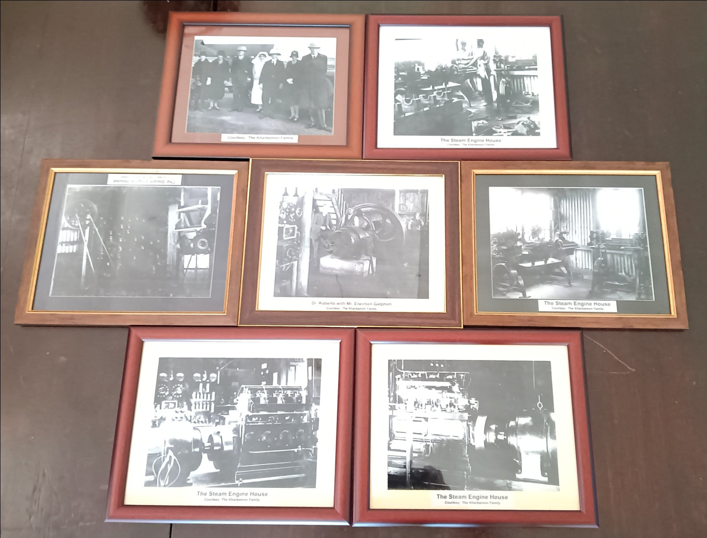

OLD TIME PHOTOGRAPHS OF THE HOSPITAL GIFTED BY KHARBAMON FAMILY AT A FUNCTION HELD ON 12TH FEBRUARY 2023